**Face Detection**

<https://medium.com/0xcode/the-viola-jones-face-detection-algorithm-3eb09055cfc2>

<https://medium.com/@aaronward6210/facial-detection-understanding-viola-jones-algorithm-116d1a9db218>

Result

Input image:



Output image:

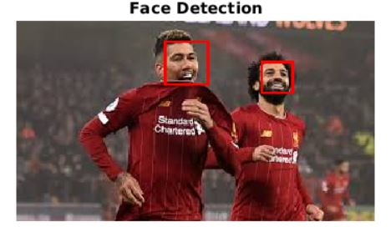

Appendix

% Face Detection using Viola-Jones Algorithm

% Muhammad Hafizuddin Bin Redzuan

% Afiqa

% Umi

% 23 June 2020

% To detect Face

FDetect = vision.CascadeObjectDetector;

% Read the input image

I = imread('face2.jpg');

%Returns Bounding Box values based on number of objects

BB = step(FDetect,I);

figure, imshow(I); hold on

for i = 1:size(BB,1)

rectangle('Position',BB(i,:),'LineWidth',2,'LineStyle','-','EdgeColor','r');

end

title('Face Detection');

hold off;